**Accessibility Measure Documentation**

**Yunguo Cai**

To investigate the influence of location, density, skill-level location, and transportation on the accessibilities, we set up a model with varying inputs to be specified. The general inputs to the model is the number of people, the number of jobs, city size, city center size, city scale (large city or small city). The accessibility measures we use are negative linear cumulative opportunity measure and exponential gravity-type measure [1]. The negative linear cumulative opportunity measure is described by Eqn. 1 and 2, where $A_{i}$ is the accessibility, $W_{j}$ is the weighted area of location $j$, $d_{ij}$ is the travel time in minutes between location $i$ and location $j$, $T$ is a constant set to 30.

$A_{i}=\sum_{j}{W_{j} ⋅f(d_{ij})}$ (1)

$f\left(d_{ij}\right)=\left\{\begin{aligned}1-\frac{t}{T}, d_{ij}<T \\ 0, d_{ij}>T\end{aligned}\right.$ (2)

The exponential gravity-type measure is described by Eqn. 3, where $β$ is a constant set to 0.12.

$A_{i}=\sum_{j}{W_{j}e^{-β⋅d_{ij}}}$ (3)

**Location Comparisons**

Location comparison consists of four models: one upper bound, one lower bound, and two models in between. For upper bound, all people live in the center of the city and all jobs are located in the center of the city. For lower bound, all households and jobs are located in the periphery of the city. Model 1 refers to the model that has people living in the center and job located in the periphery, while model 2 refers to the opposite. For all models, the number of people or household is 1000; the number of jobs are 800; the city is of size 10 by 10; the city center is of 3 by 3.

Table 1. Results of location comparison.

|  |  |  |  |  |
| --- | --- | --- | --- | --- |
|  | **Upper Bound** | **Lower Bound** | **Mode 1** | **Mode 2** |
| Gravity Measure | 0.9686 | 0.8888 | 0.9141 | 0.9136 |
| Percentage difference to lower bound | 8.97% | 0 | 2.85% | 2.79% |
| Cumulative Opportunity | 0.8958 | 0.6938 | 0.7460 | 0.7444 |
| Percentage difference to lower bound | 29.1% | 0 | 7.52% | 7.29% |

The results of the location comparison are presented in Table 1 and Figure 1-4. Based on the results, the location may have a large effect on the accessibility as the percentage difference between upper bound and lower bound is large. However, the effects of changing the location of the household position and the job position are pretty similar because the percentage difference between model 1 and model 2 is small, and the difference may due to the total number of jobs is less than the total number of household positions.

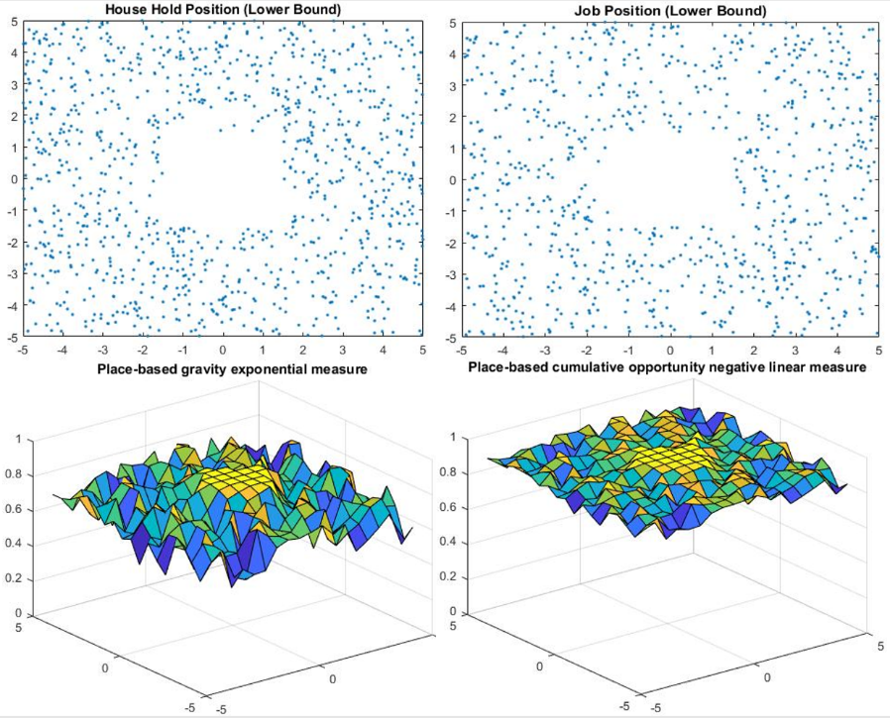

Figure 1. Household location, job position and accessibility measures of the lower bound model.

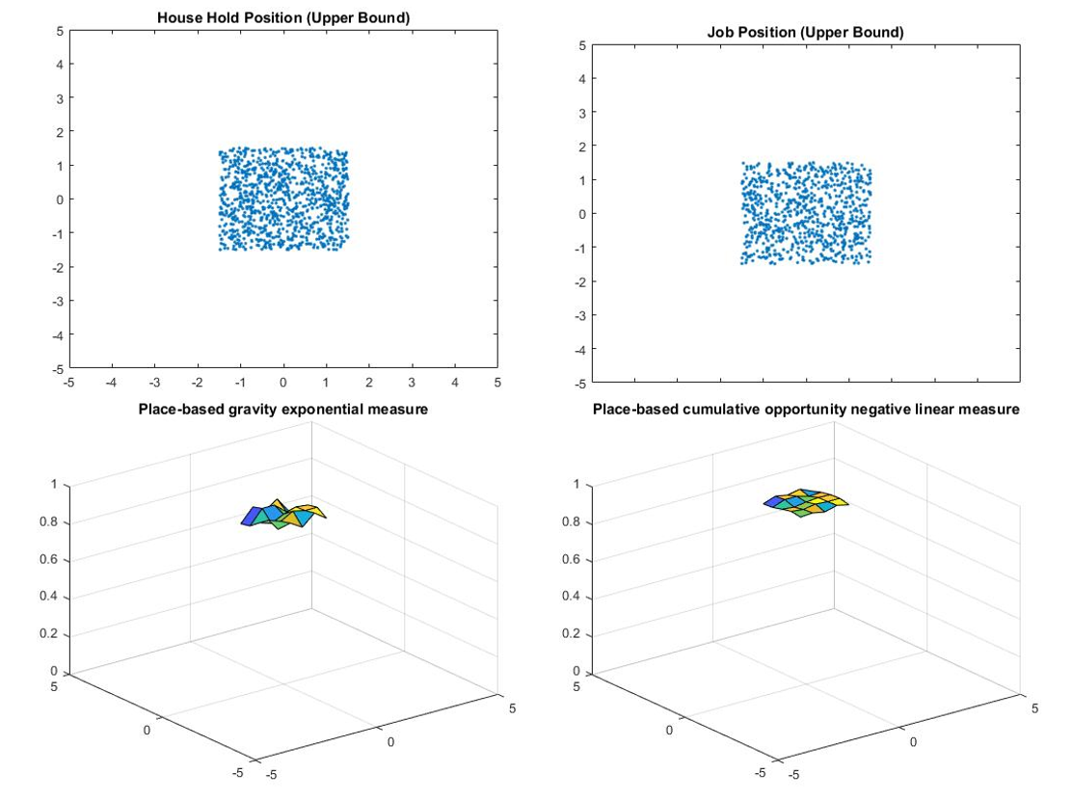

Figure 2. Household location, job position and accessibility measures of the upper bound model.

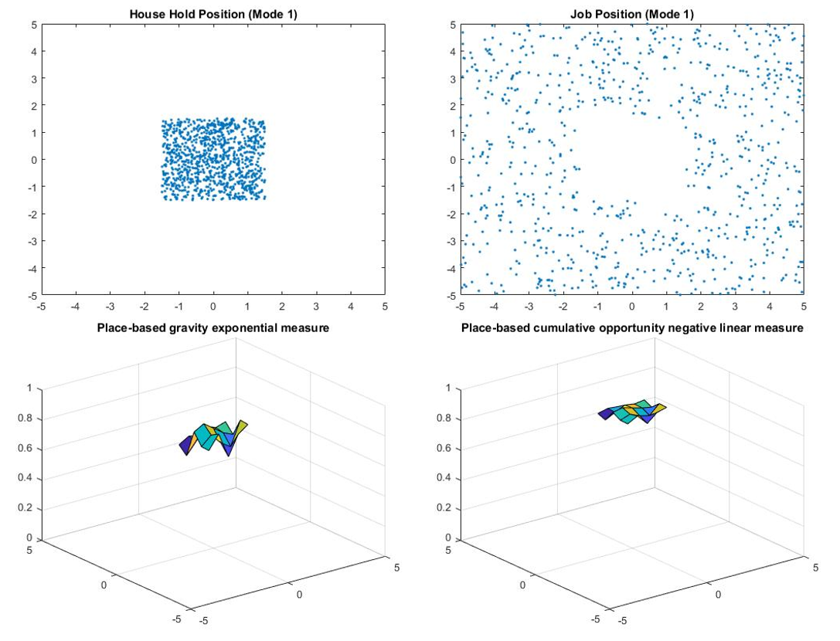

Figure 3. Household location, job position and accessibility measures of the model 1.

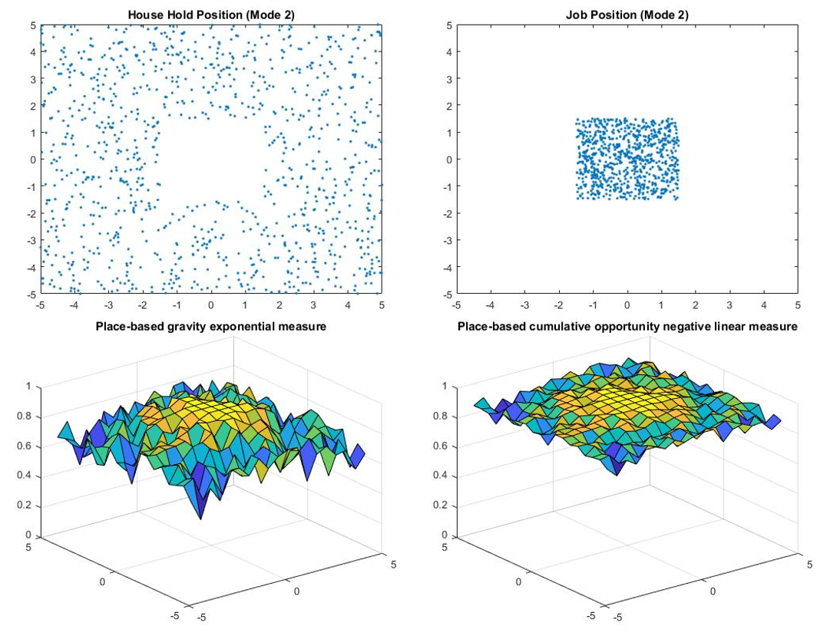

Figure 4. Household location, job position and accessibility measures of the model 2.

**Density comparisons**

For density comparisons, the model is set up with 1000 people with 3 skill levels and 800 jobs with 3 skill levels. The location of the people and jobs are assigned according to the skill levels. The people and jobs with higher skill levels will be closer to the center of the city. To investigate the influence of the job densities, the number of each skill level jobs is doubled separately. People are only able to work on the job that has skill level lower or equal to his own skill level.

Table 2. Results of density comparison.

|  |  |  |  |  |
| --- | --- | --- | --- | --- |
|  | **Original Model** | **Double Skill Level 1 Job** | **Double Skill Level 2 Job** | **Double Skill Level 3 Job** |
| Gravity Measure | 0.4984 | 0.5812 | 0.5099 | 0.4070 |
| Percentage difference | 0 | 16.6% | 2.3% | -18.3% |
| Cumulative Opportunity | 0.6023 | 0.7246 | 0.6077 | 0.4830 |
| Percentage difference | 0 | 20.3% | 0.896% | -19.8% |

The results of the density comparison are presented in Table 2 and Figure 5-8. Based on the results, the lowest skill level density has a large influence on the overall accessibility, because everyone in the city is able to work on the lowest skill level jobs. The accessibility is not sensitive to the density of the medium level jobs. The density of the highest skill level job also has a large influence on the accessibility but in the opposite direction. That is because after doubling highest skill level jobs, the weight of the available job to lower skill level people decrease, which causes the drop of the overall accessibility.

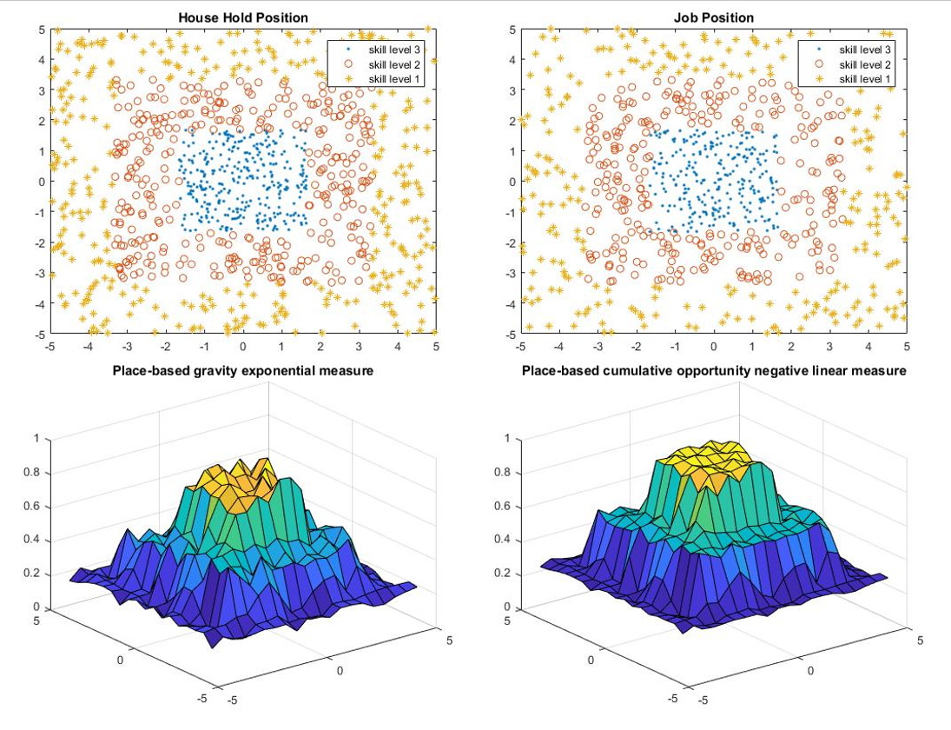

Figure 5. Household location, job position and accessibility measures of the original model.

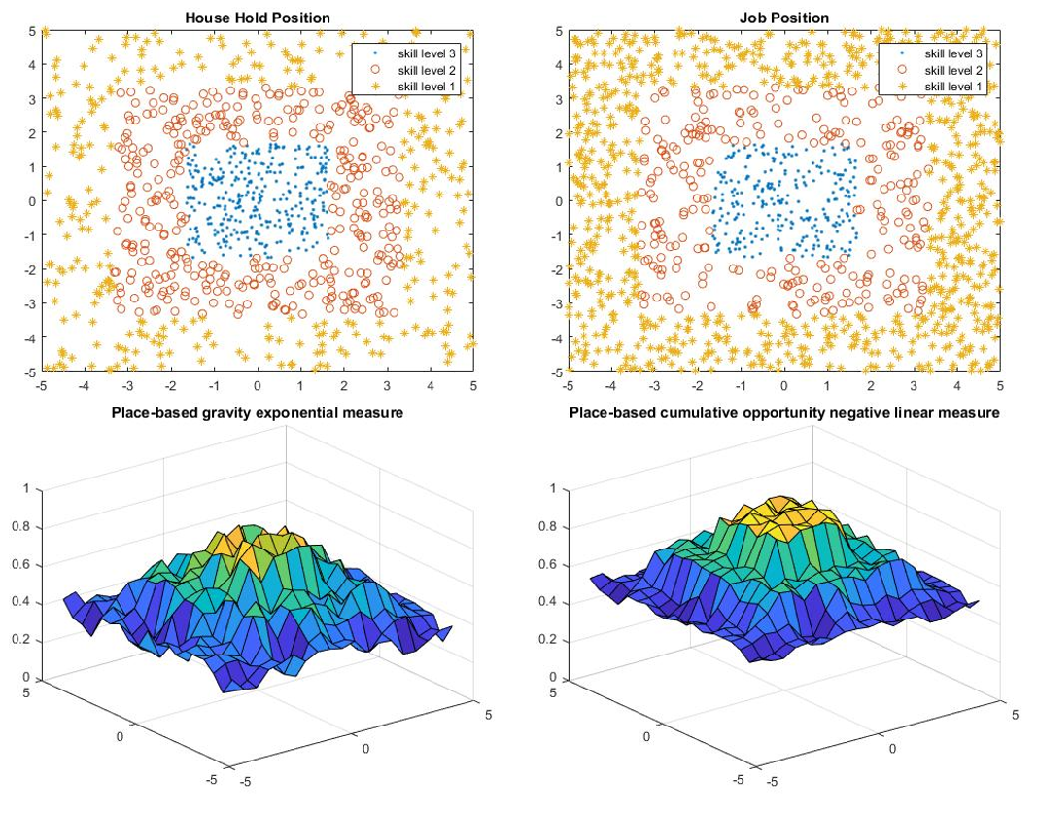

Figure 6. Household location, job position and accessibility measures after double skill level 1.

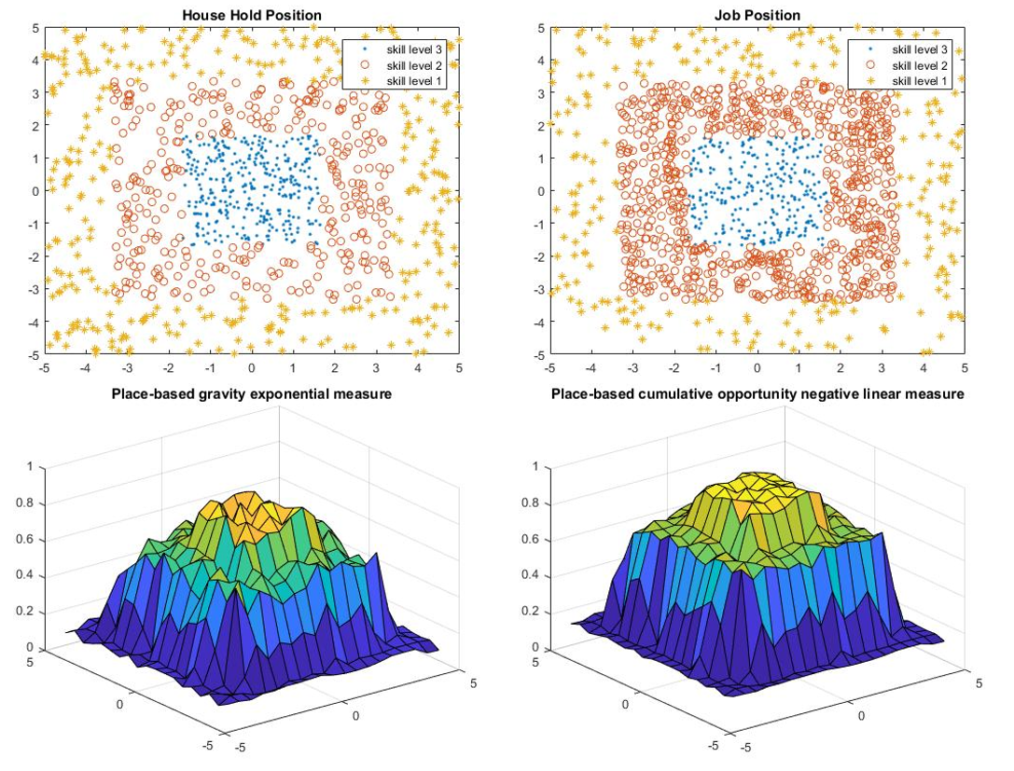

Figure 7. Household location, job position and accessibility measures after double skill level 2.

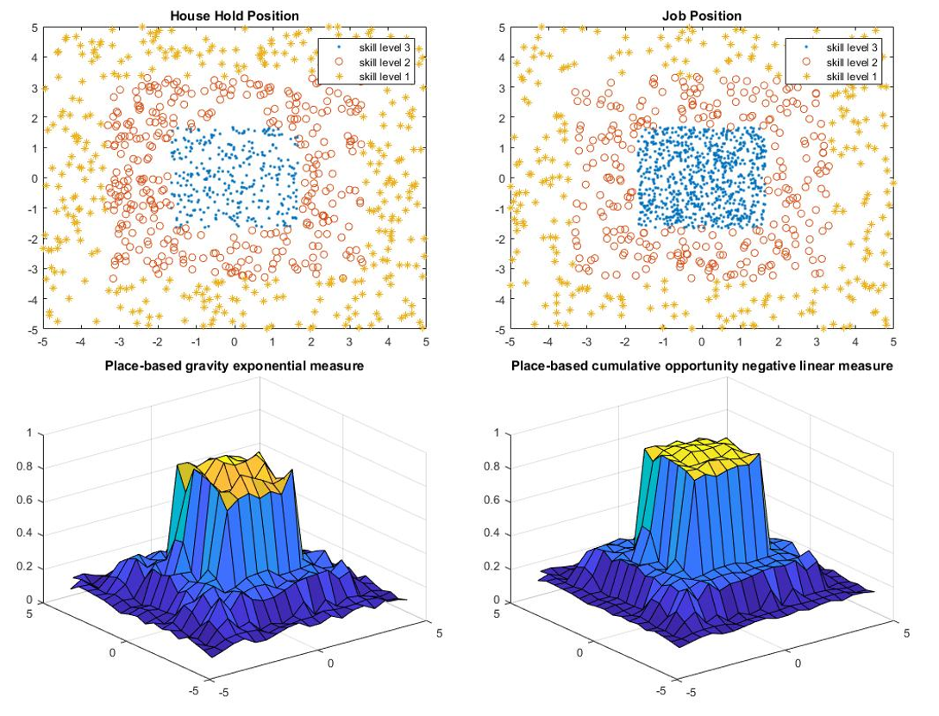

Figure 8. Household location, job position and accessibility measures after double skill level 3.

**Skill level location**

In skill level location comparisons, we further consider the city scale. People can live in any place in a city, but jobs are located in the periphery of a small city, while jobs in large city are located in the center of the city. Then the household position and job location are also distributed according to the skill level. Model 1 has both highest skill level people and jobs located in the periphery of the city, while the lowest skill level people and job located in the center. Model 2 keeps the location of people the same but switches the location of the highest skill level jobs and the lowest skill level jobs. Model 3 keeps the location of job the same with model 1 and switches the skill level location of people. Model 4 has both highest skill level people and job located in the center while the lowest located in the periphery.

Table 3. Results of skill level location

|  |  |  |  |  |  |  |  |  |
| --- | --- | --- | --- | --- | --- | --- | --- | --- |
|  | **Small City** | | | | **Large City** | | | |
|  | Model 1 | Model 2 | Model 3 | Model 4 | Model 1 | Model 2 | Model 3 | Model 4 |
| Gravity Measure | 0.4859 | 0.4775 | 0.4912 | 0.4708 | 0.5084 | 0.5302 | 0.5435 | 0.5686 |
| Percentage difference | 0 | -1.73% | 1.10% | -3.11% | 0 | 4.29% | 6.90% | 11.8% |
| Cumulative Opportunity | 0.6013 | 0.6143 | 0.6011 | 0.5857 | 0.6096 | 0.6326 | 0.6183 | 0.6444 |
| Percentage difference | 0 | 2.16% | -0.03% | -2.59% | 0 | 3.77% | 1.43% | 5.71% |

The results are shown in Table 3 and Figure 9-16. For small city, the percentage difference has opposite signs of different measures. In that sense, we may regard the difference is due to random error, which means the skill level location does not have much influence on small cities. However, for large city, we can observe that model 1 has the lowest accessibility and model 4 has the highest accessibility. The distribution of skill level of model 4 is similar to that of real world large cities, which results in the largest accessibility in terms of skill level location.

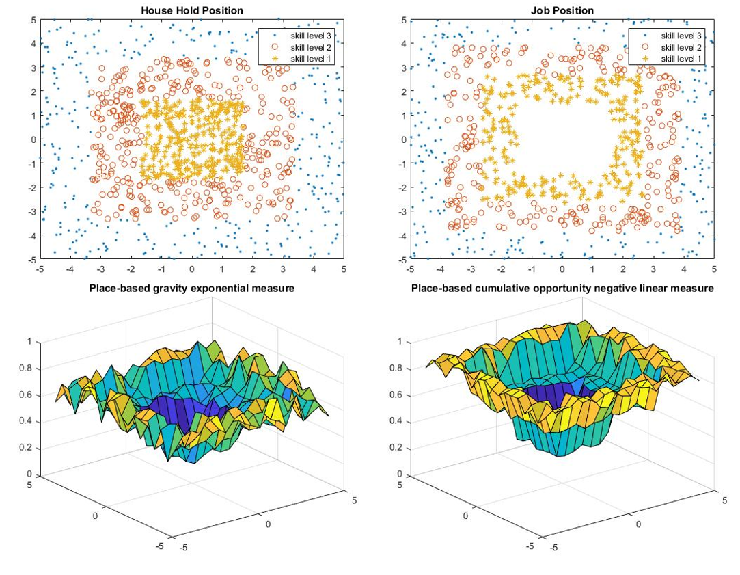

Figure 9. Household location, job position and accessibility measures of small city model 1.

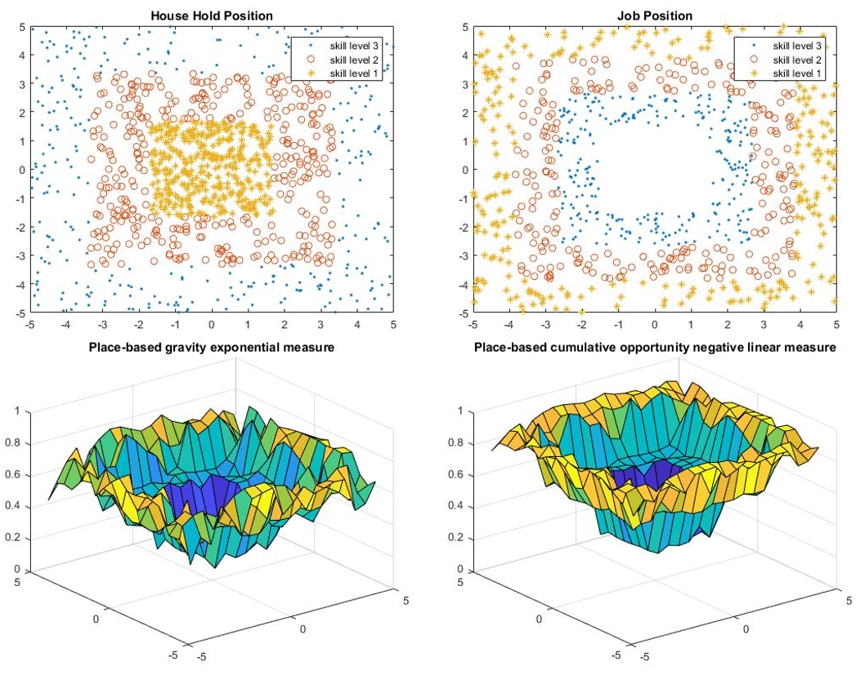

Figure 10. Household location, job position and accessibility measures of small city model 2.

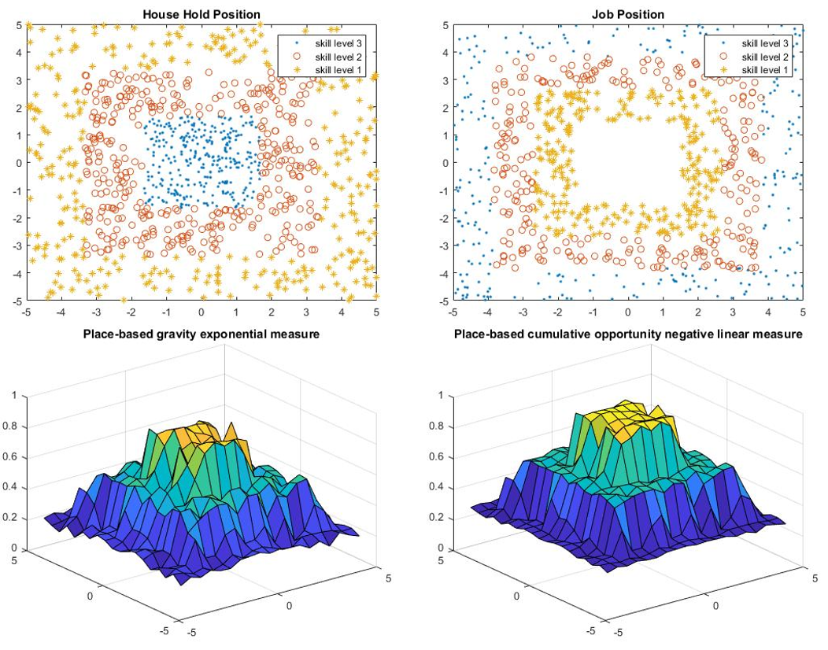

Figure 11. Household location, job position and accessibility measures of small city model 3.

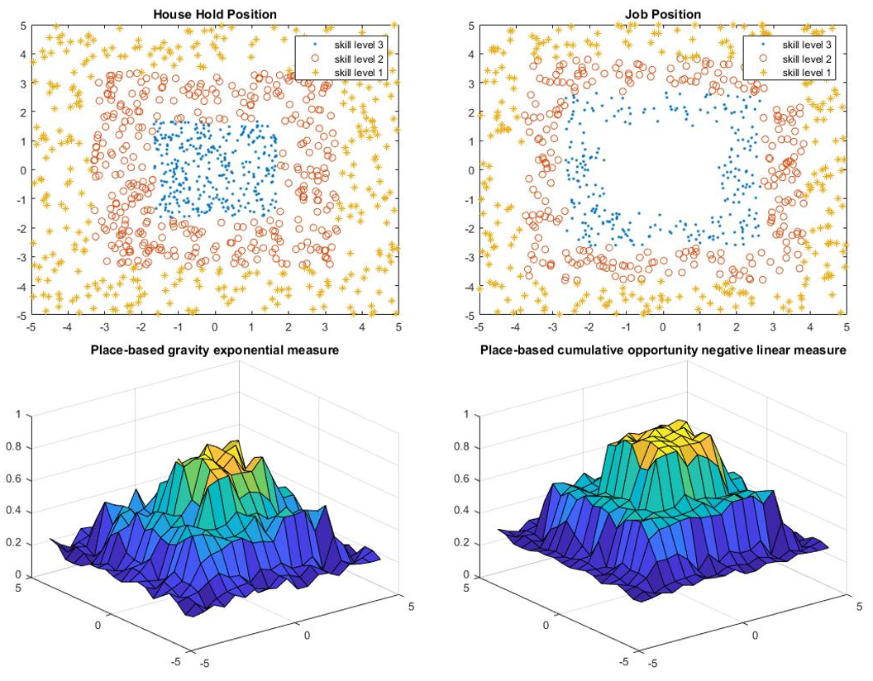

Figure 12. Household location, job position and accessibility measures of small city model 4.

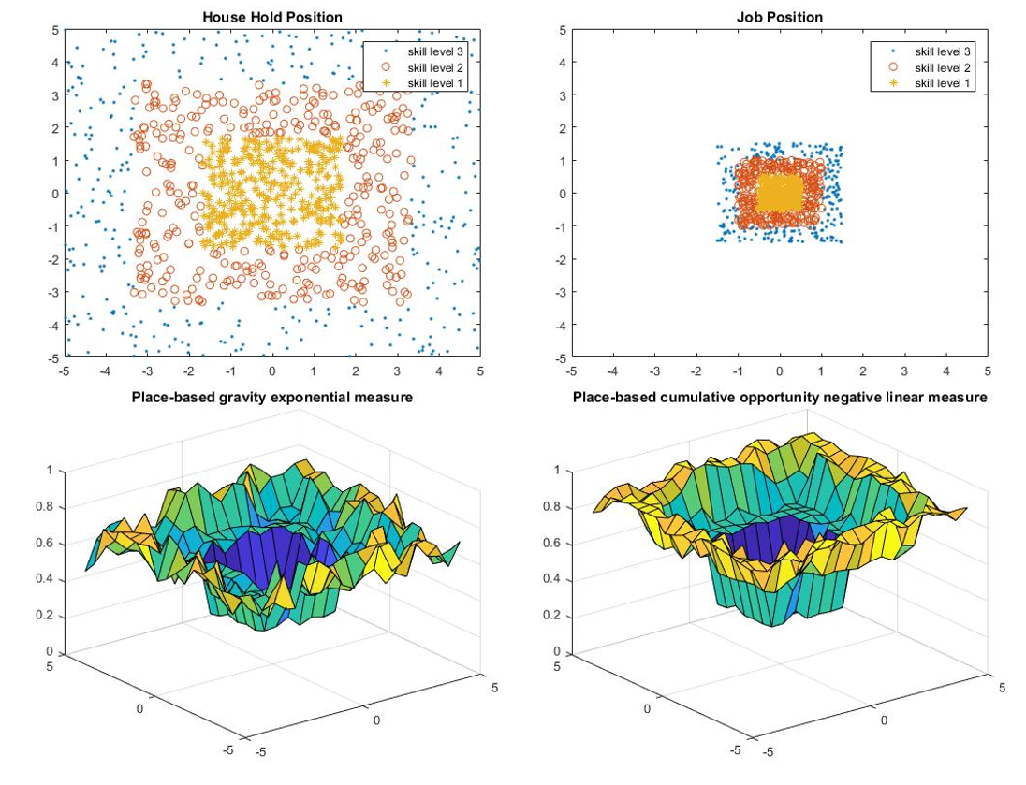

Figure 13. Household location, job position and accessibility measures of large city model 1.

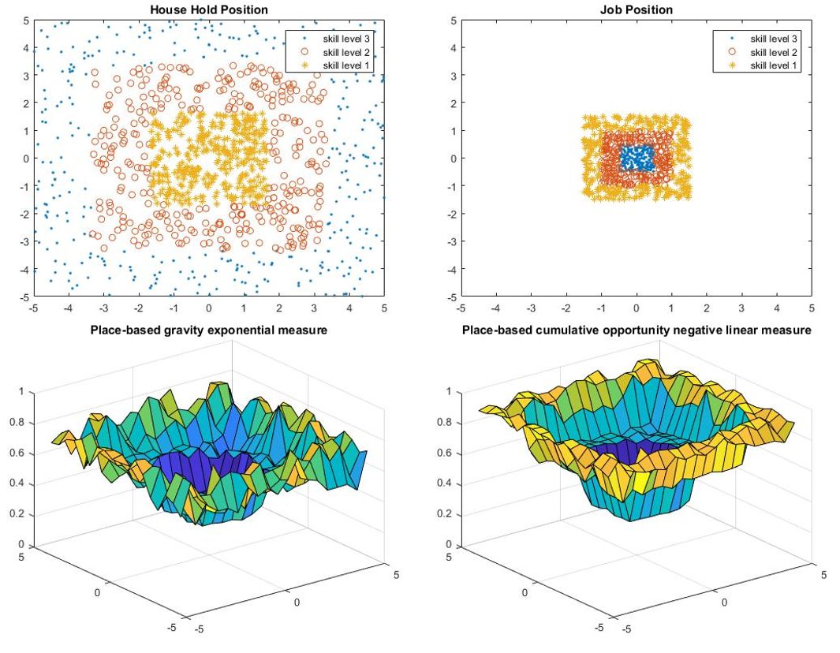

Figure 14. Household location, job position and accessibility measures of large city model 2.

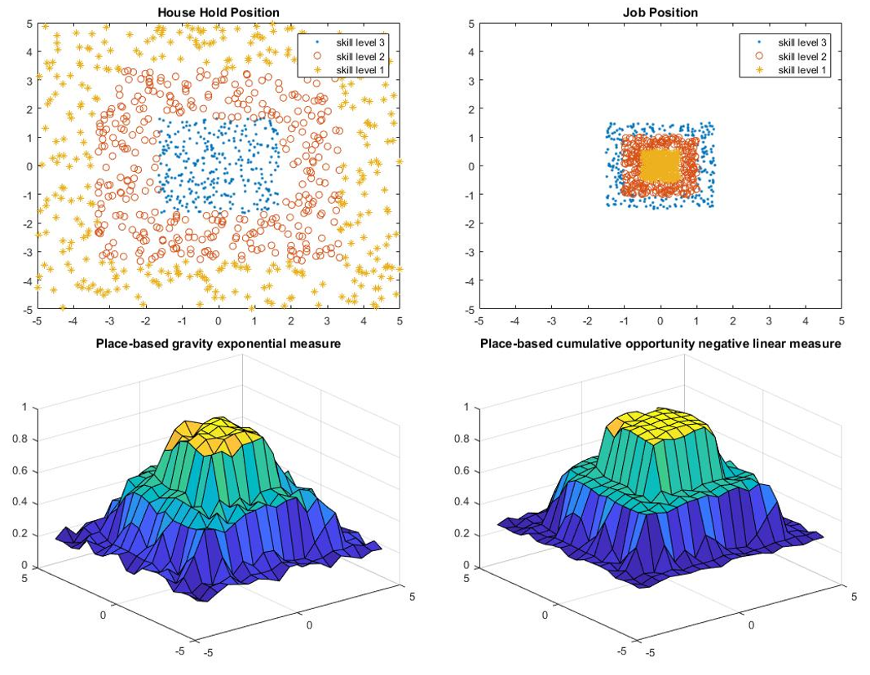

Figure 15. Household location, job position and accessibility measures of large city model 3.

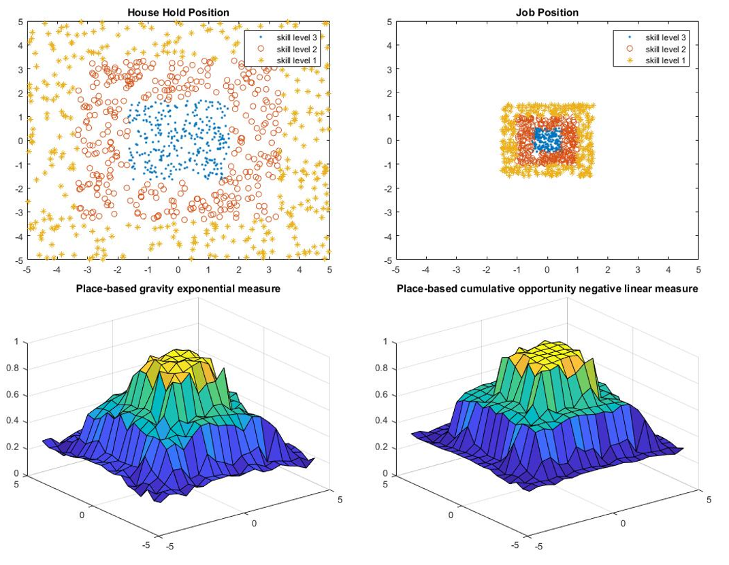

Figure 16. Household location, job position and accessibility measures of large city model 4.

**Transportation change**

For transportation change, we again consider the city scale. The household location and job location of large cities and small cities are shown in Figure 17 and Figure 18 respectively. We consider four models for transportation change. In model 1, everyone in the city drive to work (upper bound), while in model 2, everyone walk to work (lower bound). In model 3, people with skill level 3 drive to work; people with skill level 2 take bus; and people with skill level 1 walk. Model 4 is similar to model 3, and the only difference is skill level 2 people drive or take bus to work.

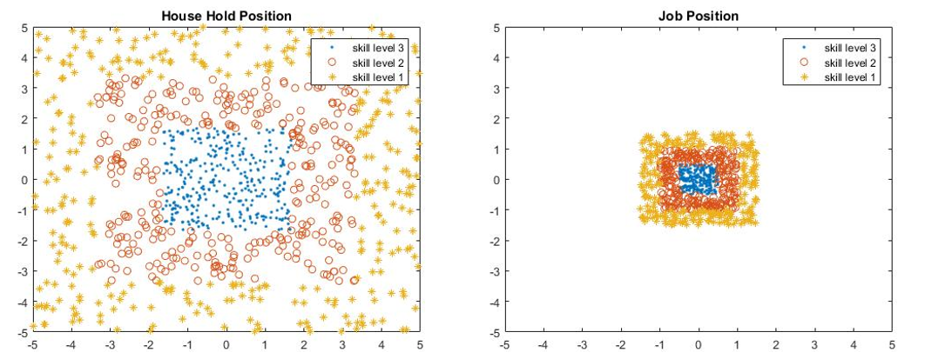

Figure 17. Household and job location of large city.

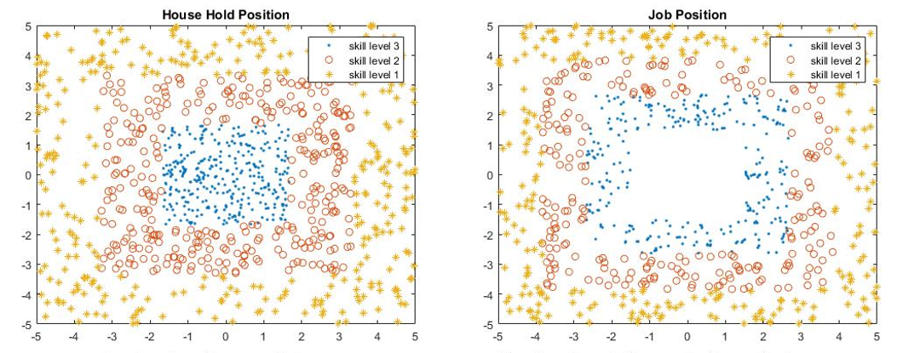

Figure 18. Household and job location of small city.

Table 4. Results of transportation change

|  |  |  |  |  |  |  |  |  |
| --- | --- | --- | --- | --- | --- | --- | --- | --- |
|  | **Small City** | | | | **Large City** | | | |
|  | Model 1 | Model 2 | Model 3 | Model 4 | Model 1 | Model 2 | Model 3 | Model 4 |
| Gravity Measure | 0.5523 | 0.3907 | 0.5184 | 0.4879 | 0.5962 | 0.5009 | 0.5446 | 0.5484 |
| Percentage difference | 41.4% | 0 | 32.7% | 24.9% | 19.0% | 0 | 8.72% | 9.48% |
| Cumulative Opportunity | 0.6289 | 0.5569 | 0.6247 | 0.5966 | 0.6408 | 0.6157 | 0.6167 | 0.6229 |
| Percentage difference | 12.9% | 0 | 12.3% | 7.13% | 4.08% | 0 | 0.16% | 1.17% |

The results are shown in Table 4 and Figure 19-26. Note that for different models, the accessibility measure has the similar shape, and only the magnitude changes. Generally, transportation mode has a large influence on the accessibility. The influence is especially obvious in small city. Since the travel distance for skill level 2 people is relatively small in large city, there will not be much difference between driving or taking bus, so the accessibilities of model 3 and model 4 are similar to each other.

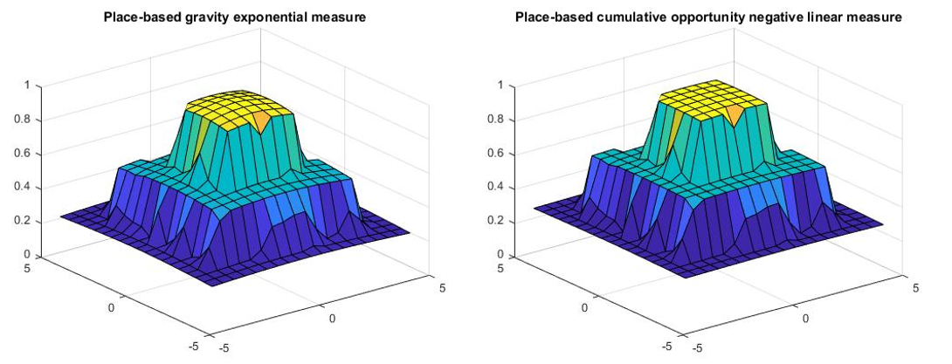

Figure 19. Accessibility measures of large city model 1.

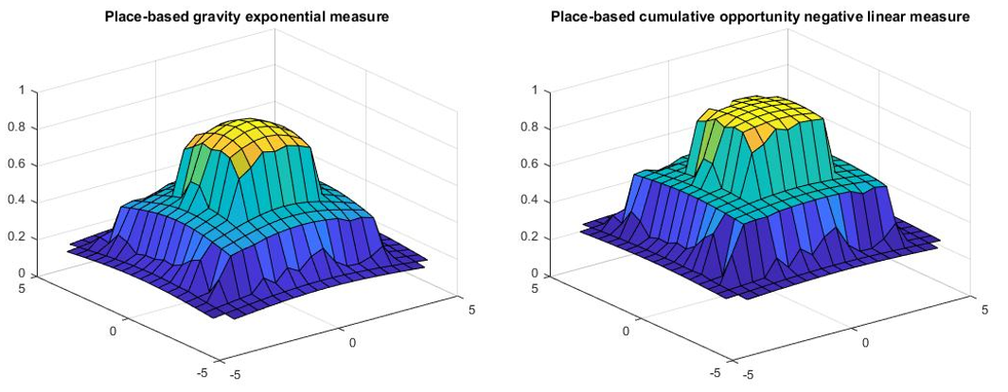

Figure 20. Accessibility measures of large city model 2.

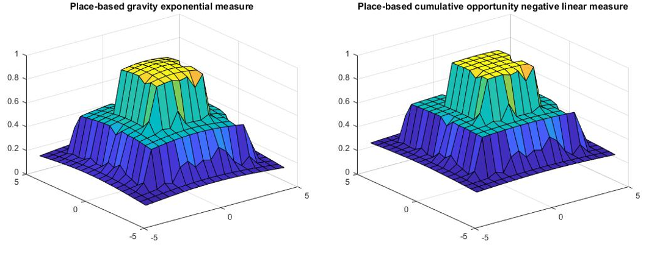

Figure 21. Accessibility measures of large city model 3.

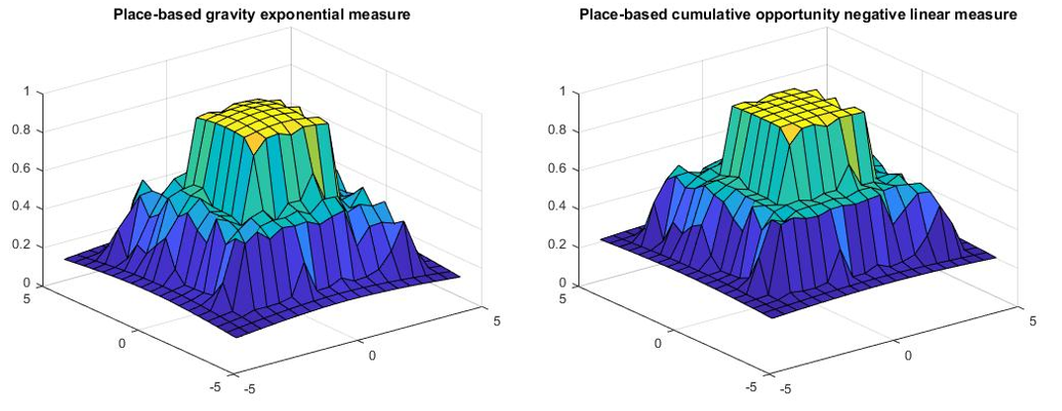

Figure 22. Accessibility measures of large city model 4.

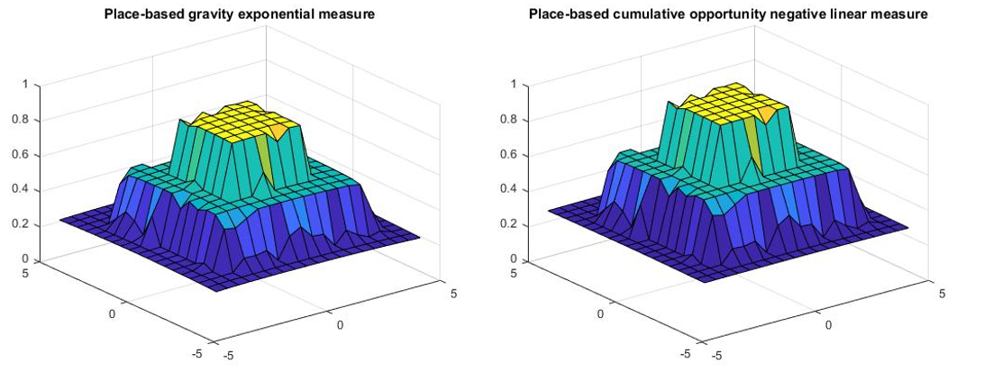

Figure 23. Accessibility measures of small city model 1.

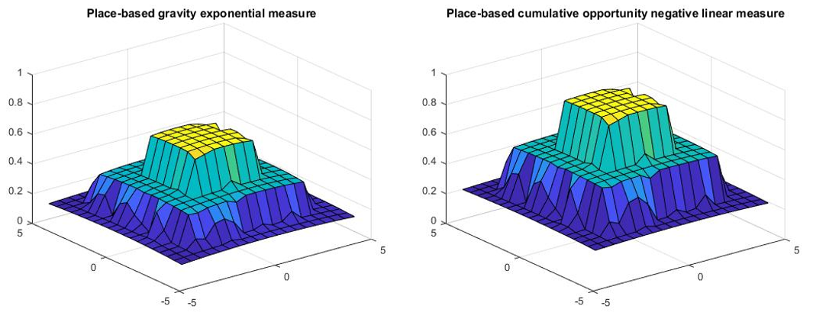

Figure 24. Accessibility measures of small city model 2.

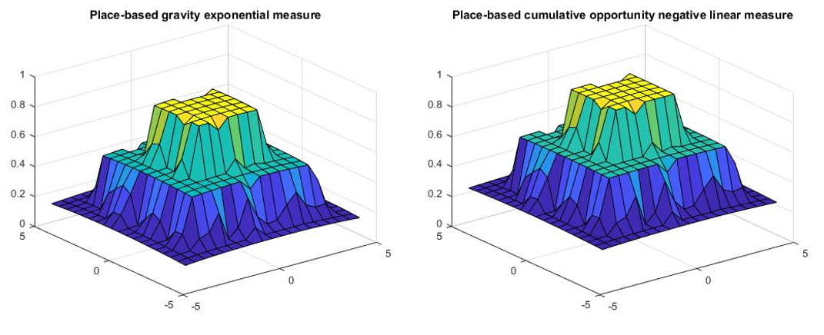

Figure 25. Accessibility measures of small city model 3.

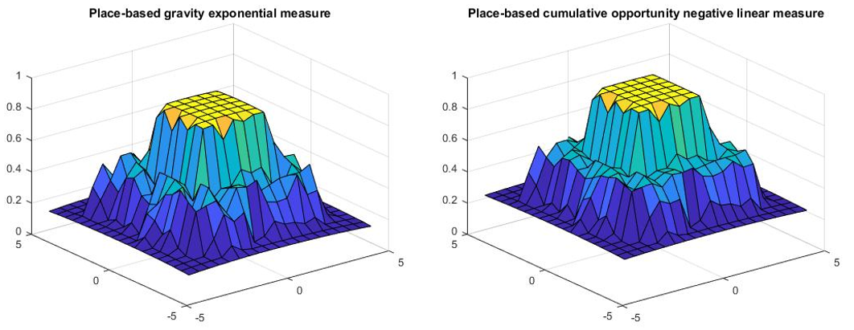

Figure 26. Accessibility measures of small city model 4.

REFERENCES

[1] Bhat, M., Handy, S., Kockelman, K., and Mahmassani, H. “Assessment of Accessibility Measure.” Center for transportation research. University of Texas at Austin.